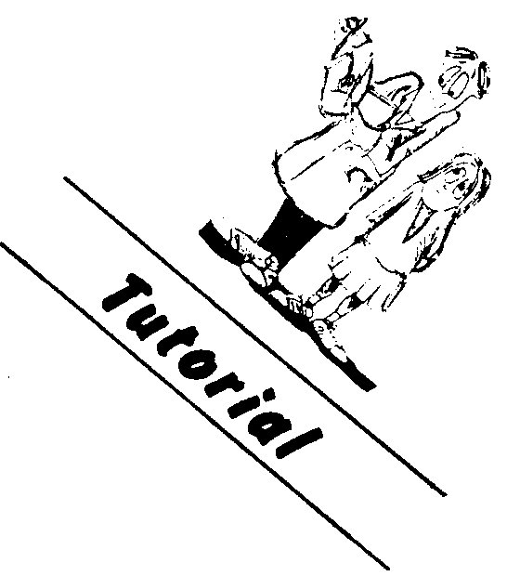

PHYSICS

ELECTRIC CURRENT

Write the letter of the answer to each question in the box.

1. Three 6.0 Ω resistors are connected in series. Their total resistance is

(a) 2.0 Ω (b) 6.0 Ω (c) 12 Ω (d) 18 Ω

2. In which circuit would all the ammeters, labelled A, read the same ?
(a)
(b)
A
2 Ω
A
A
6 Ω
A
2 Ω
A
A
6 Ω

3. In which circuit would all the voltmeters, labeled V, read the same ?
V
V
(a)
(b)

2 Ω
2 Ω

6 Ω
6 Ω
V
V

4. A 5.0 A current flows through a 10 Ω resistor. The voltage drop across this
resistor is
(a) 0.50 V (b) 2.0 V (c) 15 V (d) 50 V

5. A 1.0 Ω resistor , a 1000 Ω resistor and a 2000 Ω resistor are connected
in parallel. The total resistance is _________ Ω.

(a) <1.0 Ω (b) >1000 Ω (c) >2000 Ω (d) >3000 Ω

6. Which circuit would draw the most current ?
(a)
(b)
4 Ω
4 Ω
4 Ω
4 Ω
8 V
8 V
4 Ω

7. Which circuit would draw the most current ?
(b)
4 Ω
4 Ω
8 V
(a)
4 Ω
8 V
4 Ω

8. Will the 15 A fuse blow in the circuit drawn below ?

(a) yes (b) no
4 Ω
4 Ω
24V
4 Ω
M
M
M
15 A Fuse
6 A
6 A
6 A

9. Which change in a circuit would reduce the current flow ?
(a) increase resistance
(b) increase voltage
(c) decrease resistance

10. Which letter is on the negative side of the battery shown below ?
A
B

11. Which meter in the circuit below is an ammeter.
4 Ω
A
B

12. Increasing the voltage across the wire by a factor of three will change the resistance in the wire by a factor of:

(a) 1 ÷ 9 (b) 0.5 (c) 1 (d) 3

13. What is meant by “the resistance in an electric circuit”?

14. Why does a voltmeter have to be connected across a component that is in parallel?

15. In South London (England), the electric trains pick up their power (d.c. , at 750 V) from a third rail, the bottom of which is about 5.00 cm above the ground on insulated supports. In winter, it often happens that snow piles up to the top of these live rails, with no apparent ill effects. What does this tell you about the properties of snow ?

16. How can the switches in a car work, when there is only one wire to them ?

In the space provided, write the answer that best completes the statement.

17. A(n) ____________________ measures the current that is flowing in a circuit.

18. The ohm is a unit of electric ____________________ .

19. It is not practical for houses to be wired in ____________________.

20. The current in a(n) ____________________ circuit is the same everywhere.

21. In a(n) ____________________ circuit, the total resistance is less than any single resistance.

22. In a(n) ____________________ circuit each resistor can be operated independently.

23. The voltage across the branches of a(n) ____________________ circuit is the same everywhere.

24. Calculate the equivalent resistance for each of the networks below.

10 Ω
10 Ω
5 Ω
(a)
(c)
(b)
(d)
(f)
(e)
20 Ω
10 Ω
10 Ω
10 Ω
20 Ω
10 Ω
30 Ω
1 Ω
1 Ω
1 Ω
1 Ω
1 Ω
1 Ω
4 Ω
10 Ω
5 Ω
2 Ω
3 Ω
1 Ω

25. A light globe has a current of 0.250 A when connected to the 240 V mains supply. What is the resistance of the filament wire at the operating resistance of the filament wire at the operating temperature of the globe?

26. A calculator draws 0.100 A when powered by a 6.00V battery. What is the resistance of the calculator circuit?

27. A 20.0 Ω and a 30.0 Ω resistor are connected in series across a 10.0 V supply. Calculate:

(a) the total resistance of the circuit,

(b) the current in the circuit,

(c) the voltage across each resistor.

28. A 100 Ω resistor and an unknown resistor are connected in series with a 12.0 V battery. If the current in the circuit is 0.0500 A, what is the resistance of the unknown resistor?

29. Three resistors of 6.00 Ω, 18.0 Ω and 9.00 Ω are connected in parallel across a 12.0 V battery. Calculate

(a) The total resistance of the circuit,

(b) the current supplied by the battery,

(c) the current in each resistor.

30. Three electrical appliances are plugged into a power board. The current in the power board lead is 8.00 A when connected to the 240 V mains.

(a) What is the total resistance of the appliances?

(b) If two of the appliances have resistances of 60.0 Ω and 90.0 Ω, what is the resistance of the third?

31. Calculate the current in and the voltage across each resistor for each of the circuits below
(b)
4 Ω
4 Ω
12 V
4 Ω
2 A
3 Ω
2 Ω
5 Ω
4 Ω
(a)
6 V
2 Ω

